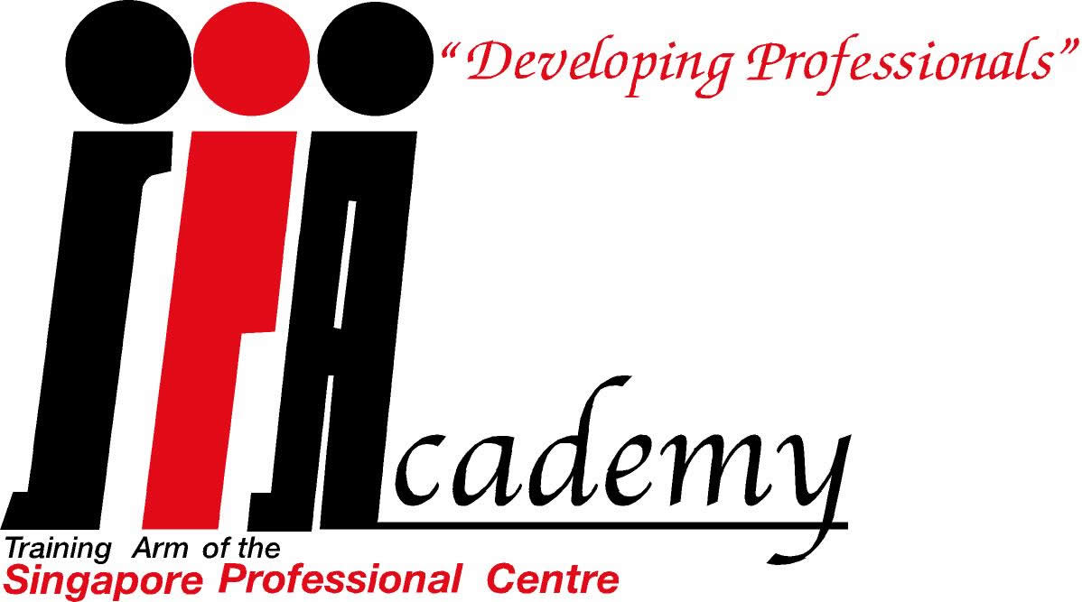

SINGAPORE
PROFESSIONAL
aCADEMY

Mission
To provide opportunities for the total professional development of
professionals and aspiring professionals through quality training
programmes to enable them to keep pace with the rapidly changing
environment.

Vision
- Platform for members facing transition in careers to channel their expertise and experience to a 2nd career as certified trainers of the Singapore Professional Academy
- Channel for member association to organise continuing professional development courses required by the self-regulatory scheme managed by the Singapore Professional Centre
- Platform for members with interests in training to embark on a ‘fall-back’ career.

The Singapore Professional Academy is open to all members of the Singapore Professional Centre. To qualify as Certified Trainers, members will have to attend the Talisman Workshop and be graded.

For more information kindly contact:

Ms Theresa Yeoh
Chief Executive
Singapore Professional Centre
Email: theresayeoh@spc.org.sg

